Whispering Hooves, LLC
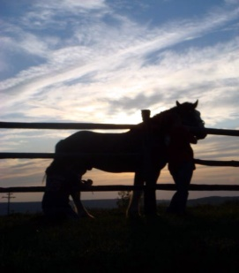
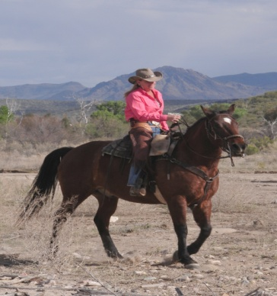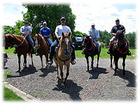
Presents
Giddy up Gang’s “Chaps and Chardonnay”
Trail Blazing Ranch Rides
WOW, roaring with fun and camaraderie!! The sounds of clip clop, birds, neighing horses and laughter surround your day. Nestled beautifully on hundreds of acres, lush meadows, scenic rolling hills, serene forests and breathtaking views located in Jamesville, NY. The only real western guest ranch in the Northeast, named
The Hilltop Ranch. Stay at an authentic ranch, stay overnight, ride half or all day long building confidence and friendships. Take rides to the local tavern and sunset rides with the cow folk; enjoy wonderful accommodations, great food, and gentle sure-footed horses. Recap in the evening at happy hour with stories and song of the day, with the instruction of your host Katherine Barbarite of Whispering Hooves, LLC. Feel like you are out west but with the convenience of only a drive away. Karaoke and dancing by the camp fire, just add color. For further information please contact Kathy at #631-764-7515 or email kathy@whisperinghooves.com . We plan accordingly to your wants and needs. Hurry an opportunity not to be missed, fills up quickly!! Please feel free to share this with friends and colleagues.
Dates: SEPTEMBER 11-13, 2009 SEPTEMBER 18-20, 2009 OCTOBER 16-18, 2009
Package Details: 3 days 2 nights (sample: Friday- Sunday)
Itinerary: Friday- Check in at 2pm, Happy Hour, Dinner, Sunset Ride
Saturday-Breakfast, all day ride w/packed lunch, happy hour, dinner, hot tub
Sunday- Breakfast, ride 2 ½-3 hours, lunch, depart w/ new friends
Includes: 6 meals, use of facility, horses and equipment, accommodations, hot tub, BYOB
Pricing: $480 per person (15% gratuity not included)

Contact:
Whispering Hooves, LLC® www.whisperinghooves.com
Katherine Barbarite kathy@whisperinghooves.com
(631)764-7515

